Image | 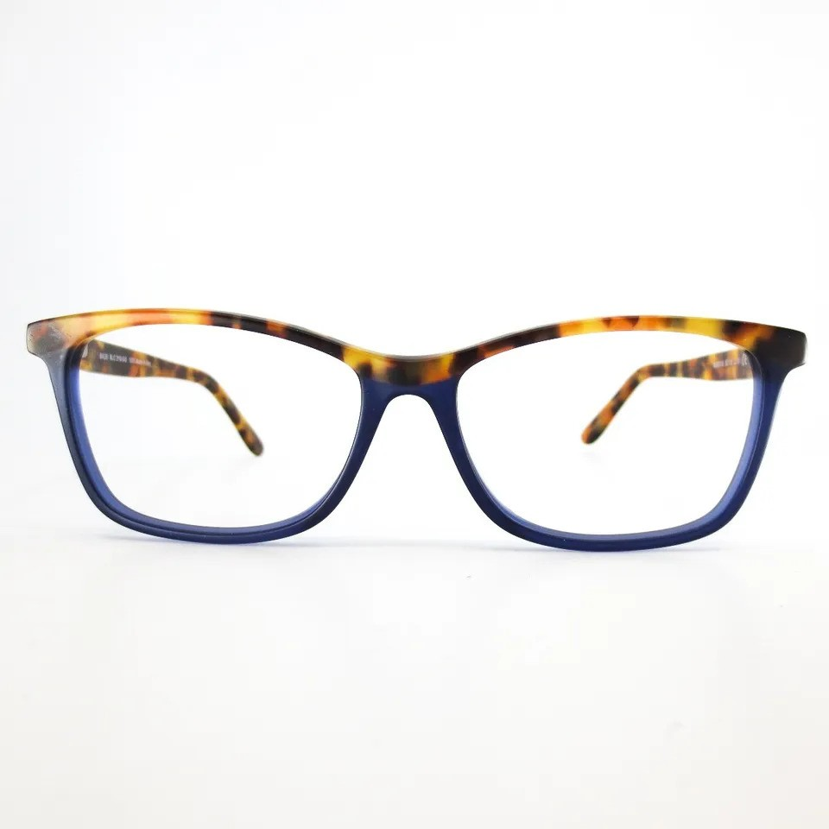
Brand | TIFFANY & CO.
Model Name | MJ 02110
Price | RS 2499
PRODUCT DETAILS

